Organizing
Your
Personal Finances
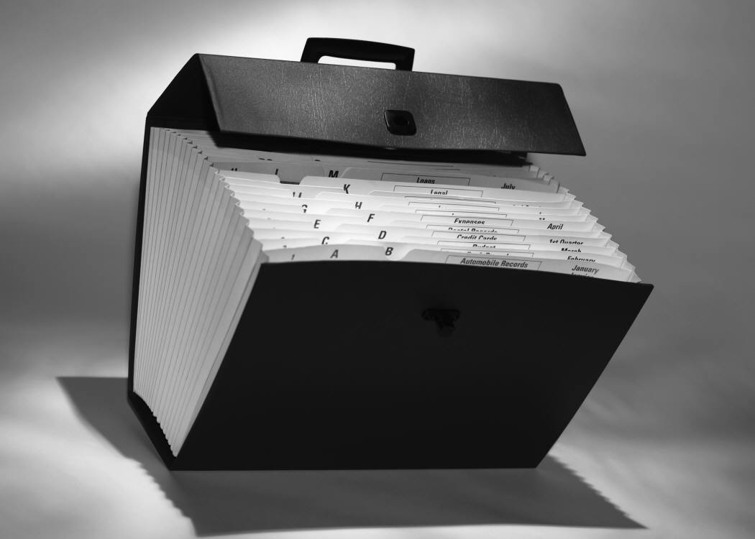







Organizing Financial Paperwork

Getting Organized

We’ve likely all thought about what we would grab should a tornado strike, a flood or fire threaten our home; favourite photos, the family pet or any number of nostalgia items. But what would be the most helpful as you try to reorganize once the emergency is over? What information do you need to have at hand if a disaster or emergency arises and your home becomes inaccessible?

The following chart provides an outline of what information you should save and where it should be stored. A financial binder is a starting place for what documents you should have at home and what will be easily taken when you leave your home in an emergency.

Where to Store Important Documents
Safety Deposit Box | Fireproof Box at Home | Lawyer/Relative/Friend
Automobile titles | Cancelled cheques | Funeral/Burial/special instructions
Birth certificates | Recent tax records | Living will
Citizenship papers | Insurance Policies/Loan Documents | Power of attorney
Death certificates | Living will | Trust documents
List of Personal Property | Power of attorney/Personal Directives | Will (copy or original)
Education degrees/certificates | Original will | Copy of personal and professional directories
Legal documents | Trust documents
Property deeds | Warranties
Marriage documents | Copy of items in your financial binder
Military documents | Back tax records
Stocks/ bond certificates | Passport

What’s Important when organizing your records for safety and accessibility

- Valuable or hard to replace items should be stored in a safe place such as a safety deposit box at a financial institution
- A lawyer, executor, relative or friend who might assist in case of your incapacitation or death should have easy access to documents that may be needed
- A system of keeping track of important papers will save hours of searching and allow you to cope more effectively in emergency situations – we are calling ours a binder but you can use file folders, a memory stick, shoebox, drawer or whatever works for you
- Plan and evaluate for the storage of all papers in order to be organized.

Why Do I Need A Financial Information Binder?

- Provides a quick reference for information pertaining to your financial situation
- Helps you manage your financial affairs more efficiently
- Should be updated annually or when a significant change occurs
- Store a copy of important binder information in a fireproof box at home, with a friend or use cloud electronic format with the original handy for ongoing use at home.

Suggested Binder Items

- Financial information (e.g. banking information, statements)
- Personal property inventory
- Net worth statement / spending plans
- Goal list
- Loan / mortgage documents
- Income tax information / assessments
- Rental / lease agreements
- Insurance policies (life, auto, home)
- Pension benefit statements
- Birth certificates / immunization records / social insurance cards
- Credit reports
- Pay stubs
- Personal / professional directory

Organizing Your Records

You may wish to organize your sections under tabs such as: Financial, Personal/Family, Professional, Legal Documents, Inventory, Taxes, Income Statements, Warranties, Insurance, etc. Use them according to how you decide to organize your records – make it yours!
What Money Means To Me

Money Values | Money means to me… (E.g. safety, security, freedom, choice, charity, comfortable retirement, adventure, etc.)
Money History | My parents handled money this way…
Money History | In our family money was considered…
Money Triggers | Some things that stress me out about money include…
Money Triggers | I feel tempted to buy things that are outside of my budget when…
My financial goals include:
Short term (1-3 years) |  | Medium term (3-5 years) | Long term (5 years +)
Getting financially organized is really important to me because….

SMART Goal Sheet

GOALS  List the steps you will need to take to reach your overall objective below. | S  Specific | M  Measurable | A  Attainable | R  Realistic | T  Time Frame  - Together
 | Who? What? Where? When? Why? | How much?  How Often?  How Many? | Can the goal be accomplished? How? | Is the goal doable? | When?  Who?
1.

2.

3.

Goals are fluid – they will change over time as you accomplish some, amend them or move towards others that become a higher priority. Keep all of them in perspective as you move through the life cycle and add new ones as opportunities present themselves. Try to save something for each of them on a monthly basis. Some will be short term (3 years or less) some intermediate (3-5 years) and some longer term (5+ years).

Weekly Tracking Tool
Knowing where your $ goes puts you in control of your finances.

For the Week of:

 | Mon. | Tues. | Wed. | Thurs. | Fri. | Sat. | Sun. | Total
Mortgage/Rent |  |  |  |  |  |  |  | 0
Home Insurance |  |  |  |  |  |  |  | 0
Phone |  |  |  |  |  |  |  | 0
Cable/internet |  |  |  |  |  |  |  | 0
Hydro/water |  |  |  |  |  |  |  | 0
Heat |  |  |  |  |  |  |  | 0
Transportation |  |  |  |  |  |  |  | 0
Groceries |  |  |  |  |  |  |  | 0
Day Care/Babysitter |  |  |  |  |  |  |  | 0
Allowances/Support |  |  |  |  |  |  |  | 0
Clothing |  |  |  |  |  |  |  | 0
Laundry/Dry Cleaning |  |  |  |  |  |  |  | 0
Personal Grooming |  |  |  |  |  |  |  | 0
Car payment |  |  |  |  |  |  |  | 0
Car Insurance |  |  |  |  |  |  |  | 0
Medical/Dental |  |  |  |  |  |  |  | 0
Lunch/Coffee/Snacks |  |  |  |  |  |  |  | 0
Tobacco |  |  |  |  |  |  |  | 0
Alcohol |  |  |  |  |  |  |  | 0
Recreation |  |  |  |  |  |  |  | 0
Gifts/Donations |  |  |  |  |  |  |  | 0
Reading Materials |  |  |  |  |  |  |  | 0
School |  |  |  |  |  |  |  | 0
Vacation |  |  |  |  |  |  |  | 0
Savings |  |  |  |  |  |  |  | 0
Life Insurance |  |  |  |  |  |  |  | 0
Debt payment |  |  |  |  |  |  |  | 0
Pet supplies/Vet |  |  |  |  |  |  |  | 0
Other |  |  |  |  |  |  |  | 0

Track your expenses for 4-5 weeks. Copy as needed. Add up the weekly amounts & look for ways to save money. Compare to your monthly expense amounts.
Income & Expense Statement
Date Completed:
Adjust categories to fit your needs |  |  | MONTHLY NET INCOME (Take Home)
MONTHLY EXPENSES |  |  | wages/salary
Housing rent/mortgage |  |  | wages/salary
2nd mortgage/LOC |  |  | Child tax credit
insurance- home |  |  | Child/spousal support
property taxes |  |  | Pension/Annuity
condo/strata fees |  |  | Other monthly income
Utilities power
heat |  |  | Other regular income (Mo. Aver.)
water & sewer |  |  | Investment Income (Mo. Aver.)
garbage pickup |  |  | TOTAL MONTHLY INCOME (2) | $ -
telephone - land line & cell phones
internet/cable TV |  |  | ANNUAL EXPENSES
Food groceries |  |  | Transportation
meals out- coffee, fast food & restaurants |  |  | vehicle maintenance
Household Incidentals |  |  | vehicle license and registration
bank fees, mag's, newsprs, alarm sys. |  |  | Clothing
Transportation vehicle insurance
gasoline, bus fare, parking |  |  | House Maintenance/Renovations
vehicle loan/lease payment
vehicle loan/lease payment |  |  | Education workshops
Personal child/spousal support |  |  | tuition, books, supplies, etc.
beauty, hair, grooming |  |  | certifications & memberships
 |  |  | Medical Expenses
child care& babysitting |  |  | dental, optical, orthodontics, vet, etc.
prescription & other monthly medical |  |  | chiropractor, massage, etc.
pets |  |  | Seasonal Sports & Recreation
Laundry/dry cleaning |  |  | hockey, soccer, skiing, golf, hunting
alcohol, cigarettes |  |  | piano, music, dance, etc.
lottery tickets |  |  | Gifts and Festivities
Recreation & Entertainment |  |  | Christmas/Other holidays
gym membership (s) |  |  | all other gifts - birthdays, etc.
movies, video games, electronics, etc. |  |  | weddings
 |  |  | Travel and Vacations
Life/Disability Insurance |  |  | travel for tournaments, camp, etc.
 |  |  | vacations
Personal Loans/Credit Card Payments |  |  | Income Tax (if not deducted)
 |  |  | TOTAL ANNUAL EXPENSES | $0
 |  |  | divided by 12 = per month (3) | $ -
Savings, Contributions & Donations |  |  | TOTAL MONTHLY EXPENSES
savings - short term |  |  | Monthly Expenses (1) | $ -
savings - long term (RRSP,RESP) |  |  | Plus Annual/12 (3) | $ -
tithe, donations, etc. |  |  | TOTAL (4) | $ -
Other |  |  | MONTHLY INCOME LESS EXPENSES
 |  |  | Monthly Income (2) | $ -
 |  |  | Less Monthly Expenses (4) | $ -
TOTAL MONTHLY EXPENSES (1) | $ - |  | BALANCE | $ -

Assets
Review at least once a year and make any adjustments.

Date Completed:
What You Own | $ Value
Savings/Investments
Vehicles/Recreational/Other
Home/Other Real Estate
Retirement Savings Plans
Registered Education Savings Plans
Life Insurance: Term/ Whole life |  | What will be paid  out upon death?
Term ins. = payable only upon death ex. $100,000
Whole life- what is the investment/accessible portion?
Company Pension (cash value)
check your company pension statements for
this information or see your pension administrator
Home Furnishings and Collectibles
Other Assets
TOTAL (A) | $ -

Liabilities – Net Worth
Watch your net worth grow from year to year!
Date Completed:
LIABILITIES (what you owe) | Balance Owing | Monthly Payment | Interest Rate | Maturity Date | Address | Account #
Credit Cards
Vehicle Loans/Lease Buyout
Mortgages
Personal Loans
Overdrafts
Student Loans
RSP Investment Loans
Tax Arrears
Property tax
CRA-Income tax owing
Arrears - other
Child/spousal support
Other Debts
Loans - family/friends
TOTAL (B) | $ - | $ -
NET WORTH
Total Assets (A) | $ -
Less  Total Liabilities (B) | $ -
Net Worth |  | $-
Important Due Date Reminder
Some expenses occur only once or twice a year. For example, car insurance premiums, property
taxes, expenses related to holidays, special events, vacations, and expenses for seasonal activities. Use this form to remind you when these occur and how much they cost, as well as tracking important anniversary dates such as mortgages so you can take advantage of no cost pre-payments.

January |  | February |  | March
Expense | Amount | Expense | Amount | Expense | Amount
Total $ | 0 | Total $ | 0 | Total $ | 0
April |  | May |  | June
Expense | Amount | Expense | Amount | Expense | Amount
File Tax Return by 30th

Total $ | 0 | Total $ | 0 | Total $ | 0
July |  | August |  | September
Expense | Amount | Expense | Amount | Expense | Amount
Total $ | 0 | Total $ | 0 | Total $ | 0
October |  | November |  | December
Expense | Amount | Expense | Amount | Expense | Amount
Total $ | 0 | Total $ | 0 | Total $ | 0

Include these as Annual Expenses on your Income & Expense Statement

Total Yearly Expenses | $
Monthly Budget Allowance  for Special Expenses | $

Tax Organizer
Place this page on the front of a large envelope for collecting your tax information over the year for preparation of your annual filing. Check all boxes that apply when submitting your information to tax professional.

- INCOME
❑ T4 - All employment income
❑ T4E Slips - Employment Insurance Benefits
❑ T4A Slips - Pension, Annuity, Old Age Security, Retiring allowances, CPP & other income
❑ T5, T3, T600 - Dividend, interest, bond and trust income (Including mutual funds)
❑ T4 RSP/RIF - All Registered Retirement Savings Plan) & Registered Retirement Income Fund
❑ Other Interest - Details of mortgage, loan, GIC, T-bill or other interest income not appearing on T5 slips, note that if you have investment instruments upon which interest is accruing but not payable at least annually, you should provide details
❑ T5013 -Partnership Income
❑ Capital Gains/Losses – Copies of brokerage statements & year-end summaries; details of sales of other capital properties (e.g. real estate, mutual funds, etc.)
❑ Rental Income -Details of rental income and expenses, and where properties have been bought and sold details of closing (proceeds on disposition, selling costs, original costs, etc.)
- Self-Employed Income - Details of self-employed income and related expenses & deductions; details of any business-related asset purchases
- Foreign Income - Details of foreign assets held & income earned including currency and taxes withheld.
- Other Income - Management fees, bonuses, alimony, support

- DEDUCTIONS
❑ Employment - Details of claims for eligible employment expenses including Form T2200 completed by employer
❑ Carrying charges - Details of all interest expenses & charges applicable to the earning of income, investment management fees, safety deposit box rental fees, etc.
- Receipted Deductions - RRSP contributions including details of any transfers and/or rollovers, union & professional dues, etc.
- Other Deductions -Details of maintenance or alimony payments, child care expenses
- Tax Advantaged Investments - Provide copies of all tax shelter financial statements, T5013 slips, loans

- TAX CREDIT CLAIMS
❑ Tuition Fees - Copies of receipts (self or supporting person) for qualifying fees paid in the year (T2202)
- Medical/Dental - Receipts for maximum advantage, note that period covered can be any 12 month period in the year
- Charitable/Political – Provide receipts
- Rent/Property Taxes –Details of rent/property taxes paid in the year if eligible and include landlord/
municipality paid
- Disability - Provide details where a claim for disability (self or dependant) exists (T2201)

- GENERAL
❑ Name and Address - Any changes in the past year
❑ Personal Information - Details of any change of marital status, new dependants
❑ Tax Instalments - Details of all instalments made in the year
❑ Assessment Notice - Complete copy of your T1 Notice of Assessment for last year (all pages)

- COMMENTS / CONCERNS / QUESTIONS – Attach any notes for your tax preparer about your tax return.

Consumer Resource List
Financial Consumer Agency of Canada www.fcac-acfc.gc.ca

Canadian Consumer Information Gateway www.consumerinformation.ca

Canadian Bankers Association www.cba.ca

Canada Education Savings Grant www.canlearn.ca

Canada Revenue Agency www.cra-arc.gc.ca

Vanier Institute of the Family www.vifamily.ca

Credit Rating (1 free personal report per year)
Equifax Canada www.equifax.ca
Trans Union of Canada www.transunion.ca

Consumer Protection by Province

Alberta: www.servicealberta.gov.ab.ca/consumer_info.cfm
British Columbia: www2.gov.bc.ca/gov/theme.page?id
Manitoba: www.gov.mb.ca/cca/cpo/
New Brunswick: www.fcnb.ca/FinancialConsumer.html
Newfoundland & Labrador: www.servicenl.gov.nl.ca/
Nova Scotia: www.novascotia.ca/snsmr/access/individuals/consumer-awareness.asp
Ontario: www.sse.gov.on.ca/mcs/en/pages/default.aspx
Prince Edward Island: www.gov.pe.ca/jps/index.php3?number=69842
Quebec: www.gouv.qc.ca/portail/quebec/pgs/citoyens/plansite/?lang=en
Saskatchewan: www.justice.gov.sk.ca/cpb
Yukon: www.community.gov.yk.ca/consumer/cp.html

